**Step 1 - Get IP address**:  
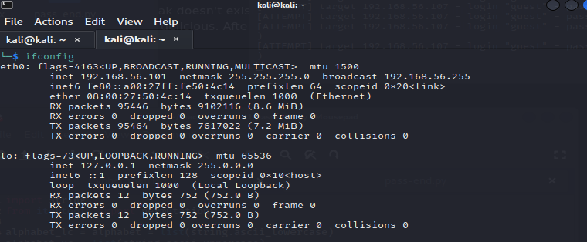 Host address is 192.168.56.101

**Step 2 – Get Victim IP:**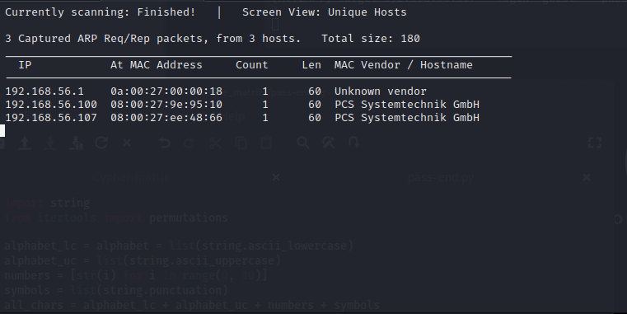Found: 192.168.56.107

**Step 3 – Nmap Scan:**

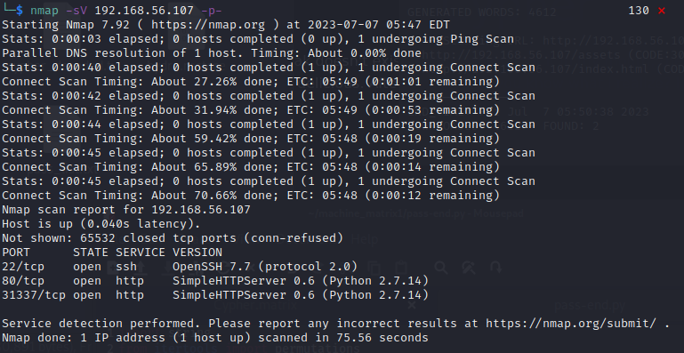 Port 31337 looks interesting

**Step 4 – Visit Site and Enumerate Subdirectories:**

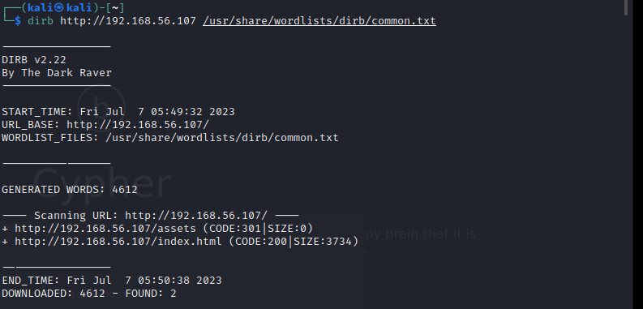 Nothing interesting

**Step 5 – Visit Port 31337:**

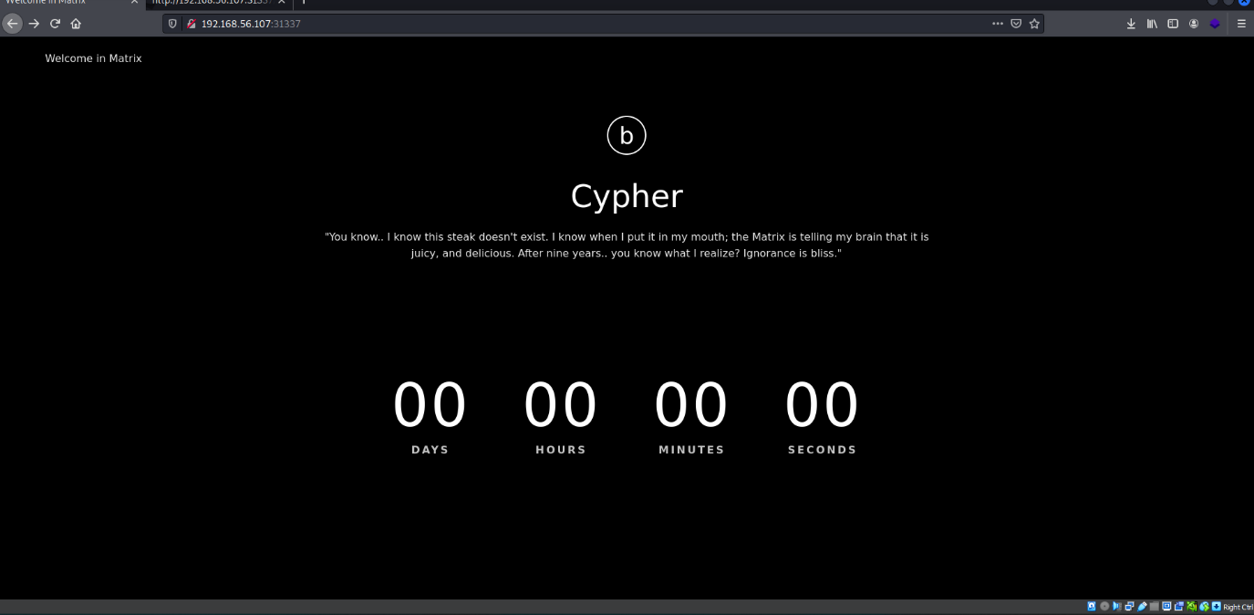 It’s a separate webpage

**Step 6 – View Source:**



Hidden Base64 hash

**Step 7 – Decode:**

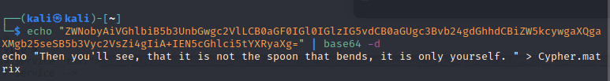

See if it is a subdirectory

**Step 8 – Add to URL:**

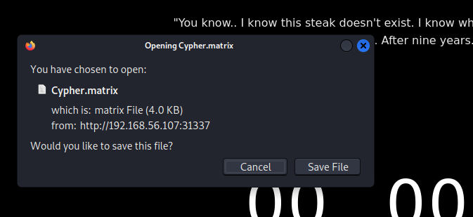

Download file

**Step 9 – Read File:**

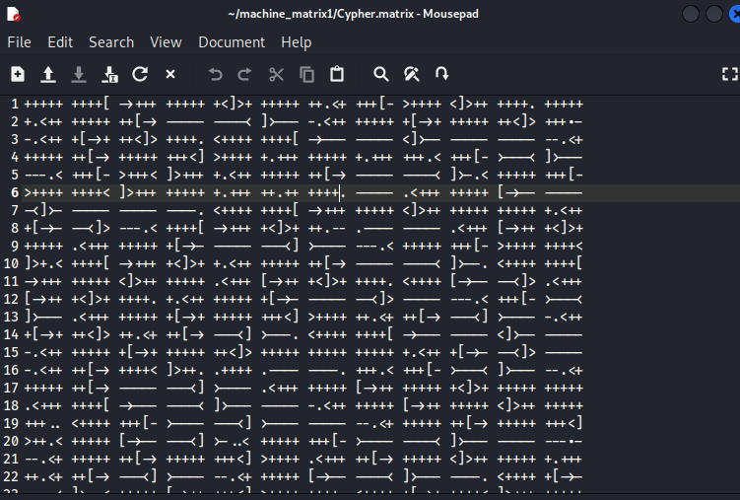

Brainfuck cypher

**Step 10 – Decode Cypher:**

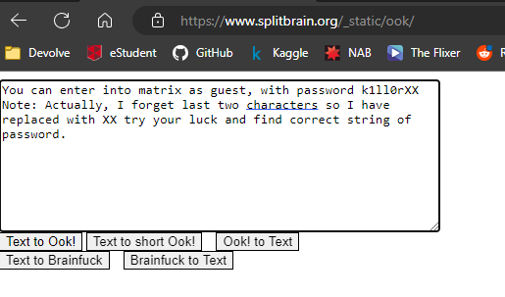

**Step 11 – Generate all possible passwords:**

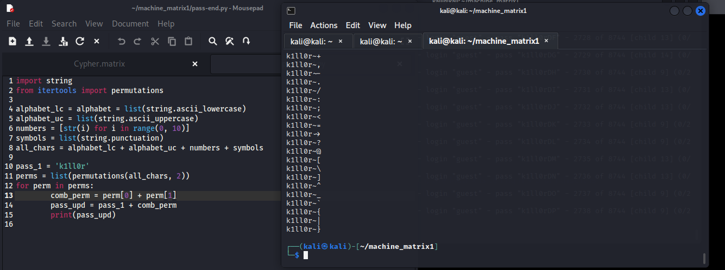

**Step 12 – Save script output to password list to use for Hydra bruteforce attempt:**

